On [DATE]
you are going to The Bunker

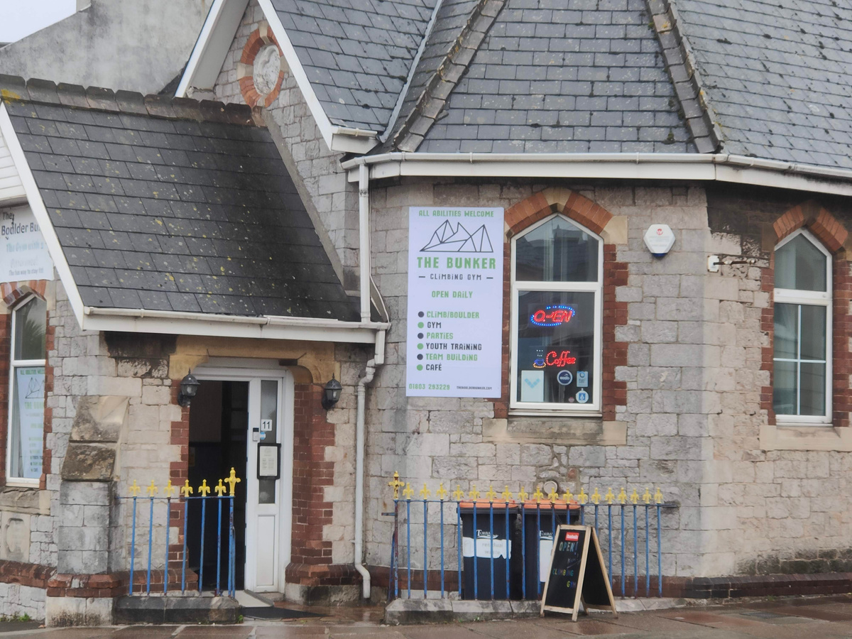

[You will come to school in your PE kit].
[INSERT YOUR PE PHOTO]
You will need your water bottle.

At [TIME] you will leave class.
You will be with [TEACHERS]for the trip.

We will travel in [XXX].
[WHO WILL DRIVE] will drive.
We will park near The Bunker.
We will walk from the [TRANSPORT MODE].
You must walk with [XXX].

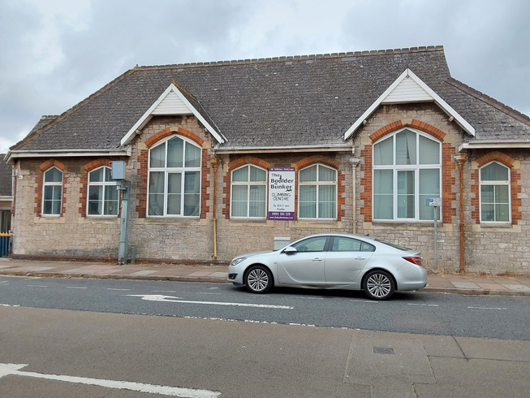
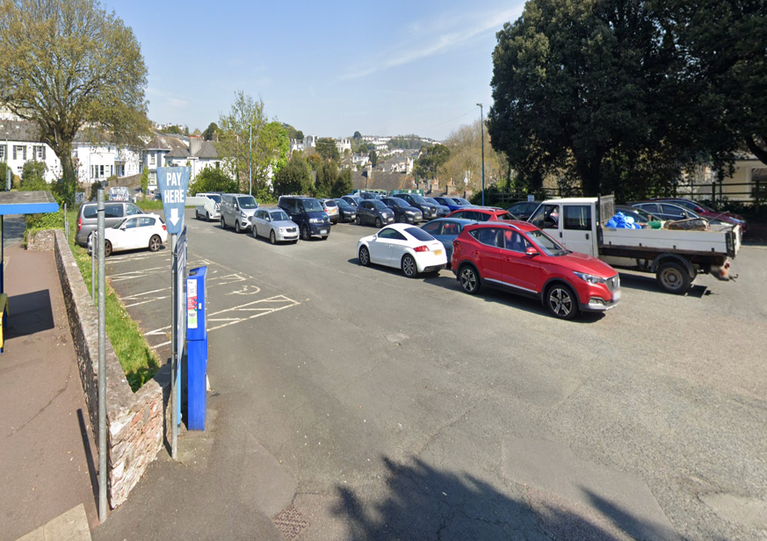
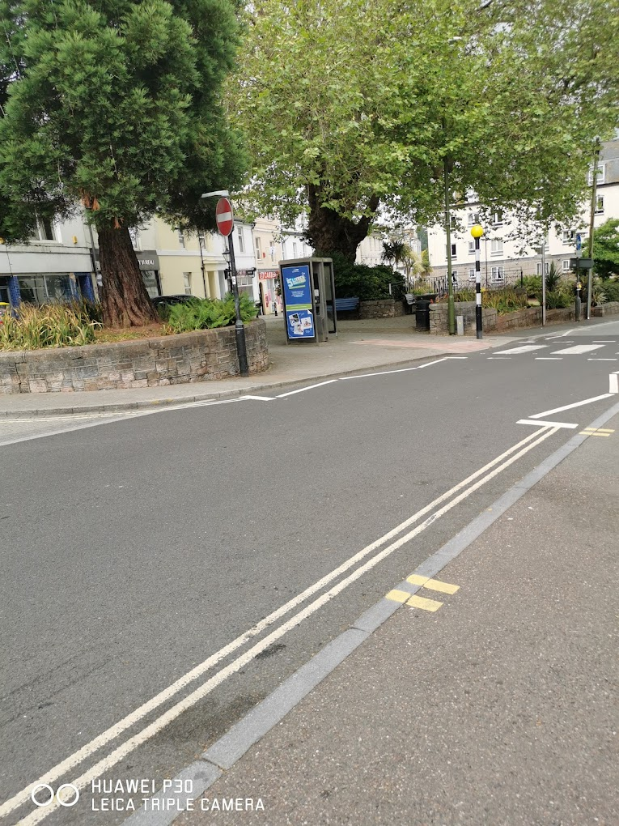

When you go inside [THE TEACHERS] will say hello to The Bunker worker at the front desk.

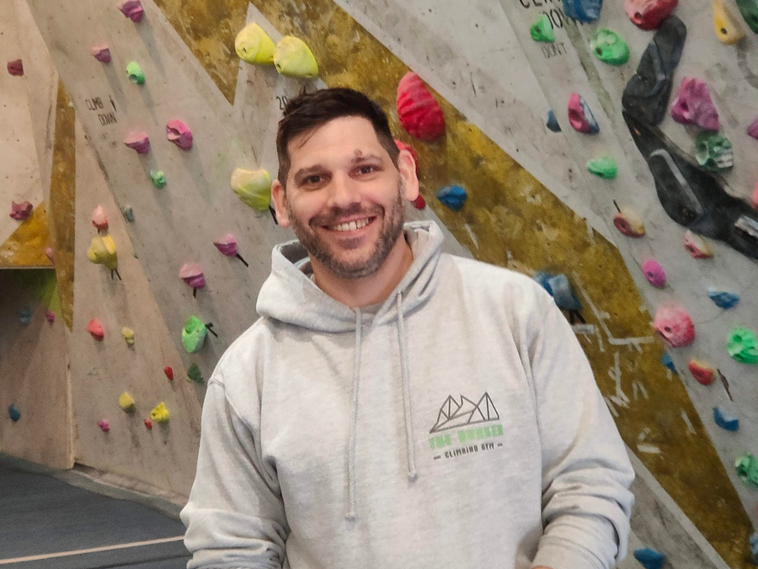

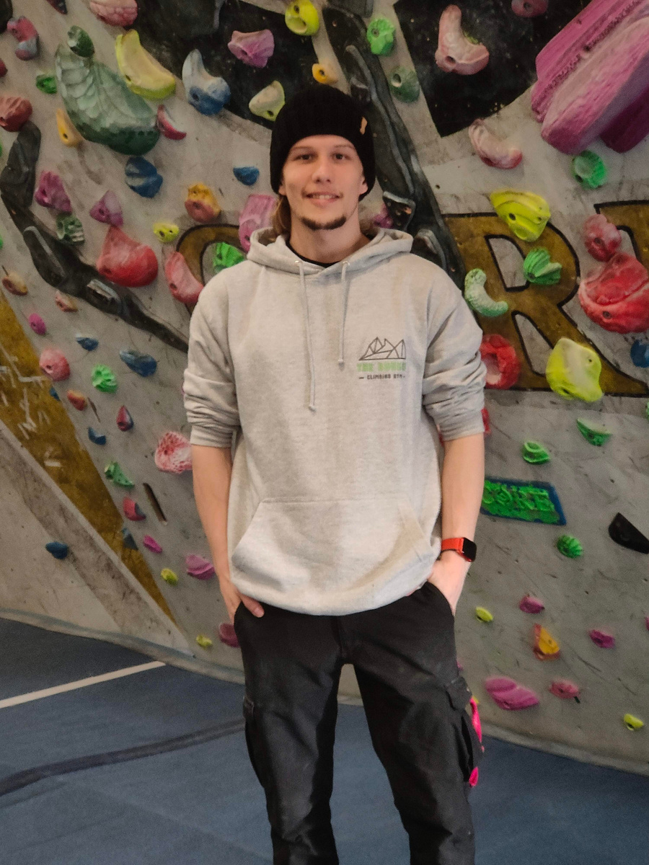

You can use the toilet if you need to before your session. You will take off your jacket so you are ready to climb.

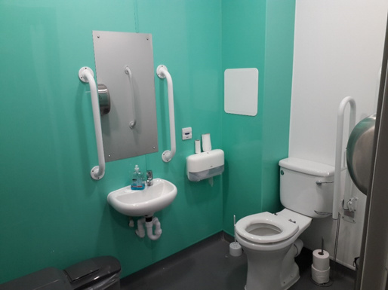

You will meet the people who will show us what to do.
They are called climbing instructors. They wear grey shirts.

You must listen to the rules.
1. Do not run



2. Do not climb under other people

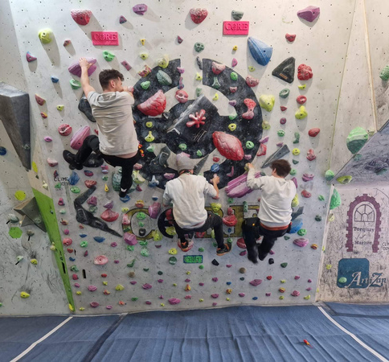

3.Do not jump of the wall

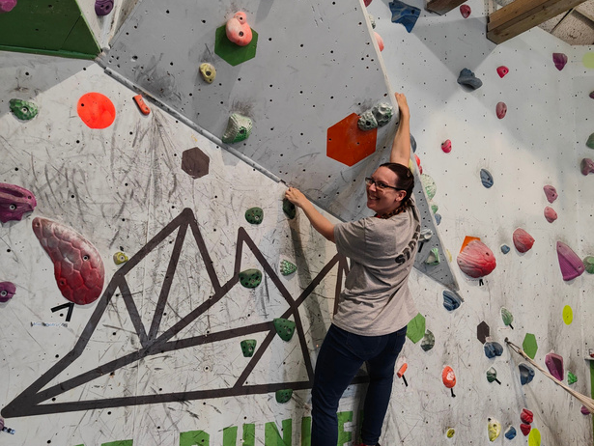

4.Do not swing on the rope

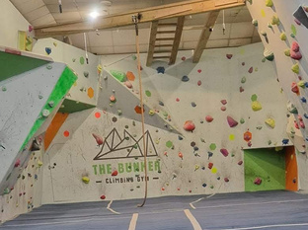

The climbing instructors will help you.
[YOUR TA/TEACHERS] can also help you.
You can choose where you climb.

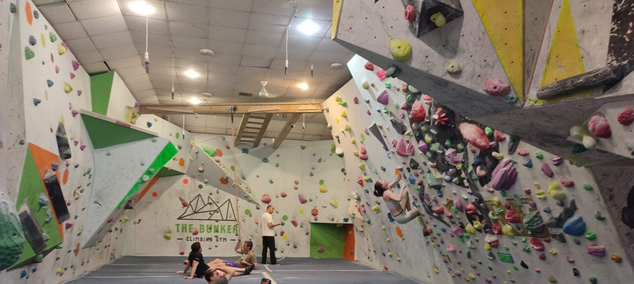

There are lots of climbing walls.

You can use the toilet if you need to.
[We will have lunch before/after climbing.]
Everyone will use the toilet
before we come back to school.

We will travel back in the [TRANSPORT].
We will arrive back in school [TIME].

